Required Textbook
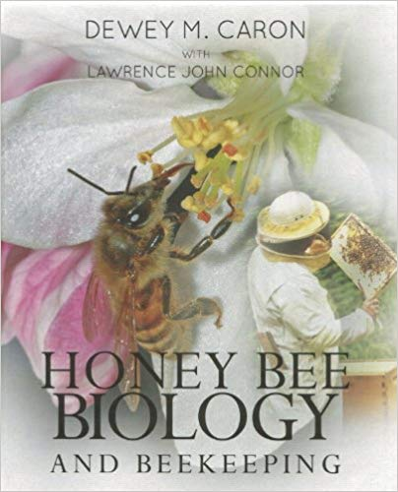
Honey Bee Biology and Beekeeping. Caron, Dewey M., and Lawrence John. Connor. Revised edition (June 28, 2013) ed., Wicas Press, 2013.
ISBN 978-1878075291 ----- Approximately $50 from Amazon.
Feel free to shop around for the book. We would recommend purchasing vs renting the book because this will also be this primary textbook for the Intermediate Beekeeping Certificate.

About our Beekeepers/Instructor

Casie Berkhouse
Casie Berkhouse began her beekeeping journey in her Grandmother’s small apiary in the Mid-hills of Pennsylvania at the age of eight, where she was allowed to manage the smoker and lick honey off the frame. After graduating from high school, she continued her educational journey to obtain an Education and a Philosophy degree, with concentrations in science and natural history. While a Philosophy student, Casie studied the interdisciplinary concepts of the intriguing social aspect of the Honey bee and how that could be applied to the human collective. Today, as an ecology and biology educator at Lackawanna College and a certified beekeeper, she maintains her own apiary and a future full of inspiring growth, learning and a love of the natural world. Her passion for beekeeping comes from a deep understanding of our environment and the role bees play in our ecosystem as a Keystone Species. In addition to beekeeping, her entomology hobbies also include line-breeding isopods, springtails and other insects for feeder purposes.

